Hive Manual

# Creating table from HDFS Isilon

# Performing a union of two tables of EPG tables

# Performing a Hive Static partition on EDR table

# Performing a JDBC connect to the Sysadm Database and performing a select query on all tables.

# Creating table from HDFS Isilon

The following has been done within the Isilon hdfs

**Created the following file paths:**

* drwxr-xr-x - root hadoop 0 2020-03-13 10:35 /test_env/test_3/staging/EMM
* drwxr-xr-x - root hadoop 0 2020-03-16 09:17 /test_env/test_3/staging/EMM_1
* drwxr-xr-x - root hadoop 0 2020-03-16 09:35 /test_env/test_3/staging/EMM_2
* drwxr-xr-x - root hadoop 0 2020-03-16 09:35 /test_env/test_3/staging/EMM_3
* drwxr-xr-x - root hadoop 0 2020-03-16 09:25 /test_env/test_3/staging/EMM_4
* drwxr-xr-x - root hadoop 0 2020-03-16 09:25 /test_env/test_3/staging/EMM_5
* drwxr-xr-x - root hadoop 0 2020-03-13 10:44 /test_env/test_3/staging/EPG
* drwxr-xr-x - root hadoop 0 2020-04-14 19:46 /test_env/test_3/partition/EPG

These paths will be dumped with both EMM and EPG files that were provided by the team for testing.

**The following tables were created running the following queries:**

CREATE EXTERNAL TABLE emm_test_1b

( recordType STRING,

recordSequenceNumber STRING,

tSC STRING,

tOS STRING,

tariffClass STRING,

bearerServiceCode STRING,

callingNpiTon STRING,

callingMSISDN STRING,

calledNpiTon STRING,

calledMSISDN STRING,

calledRawMSISDN STRING,

origCalledNpiTon STRING,

originalCalledNumber STRING,

translatedNpiTon STRING,

translatedNumber STRING,

iMEI STRING,

iMSI STRING,

dateForStartOfCharging STRING,

chargeableDuration STRING,

timeFromRegToStartOfCharge STRING,

interruptTime STRING,

timeForStopOfCharge STRING,

geo_location STRING,

cause STRING,

firstLAC STRING,

firstCI STRING,

lastCI STRING,

incomingRoute STRING,

outgoingRoute STRING

)

ROW FORMAT DELIMITED

FIELDS TERMINATED BY ','

STORED AS TEXTFILE

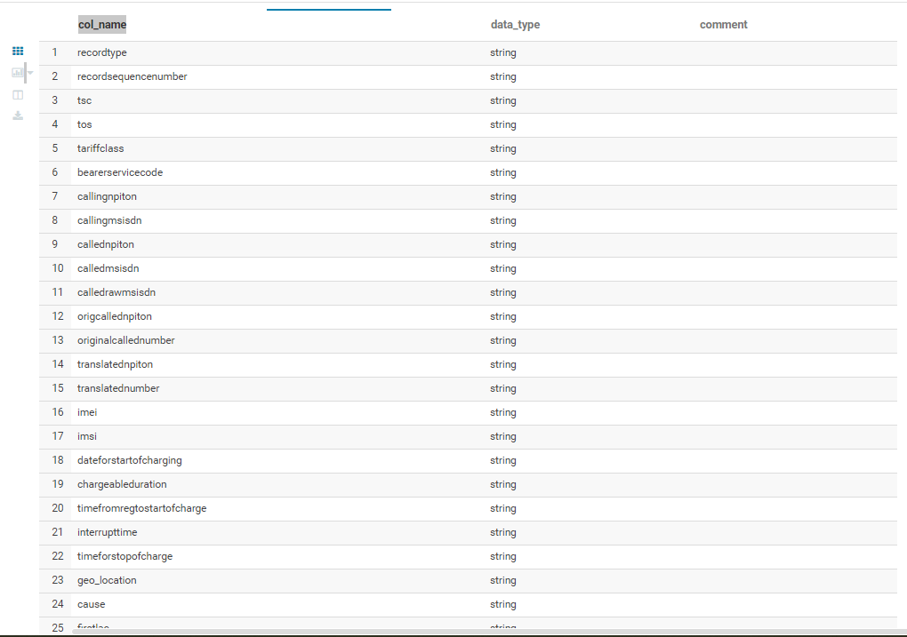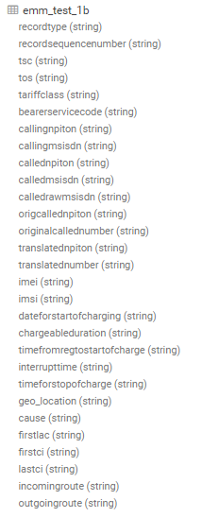LOCATION '/test_env/test_3/staging/EMM';

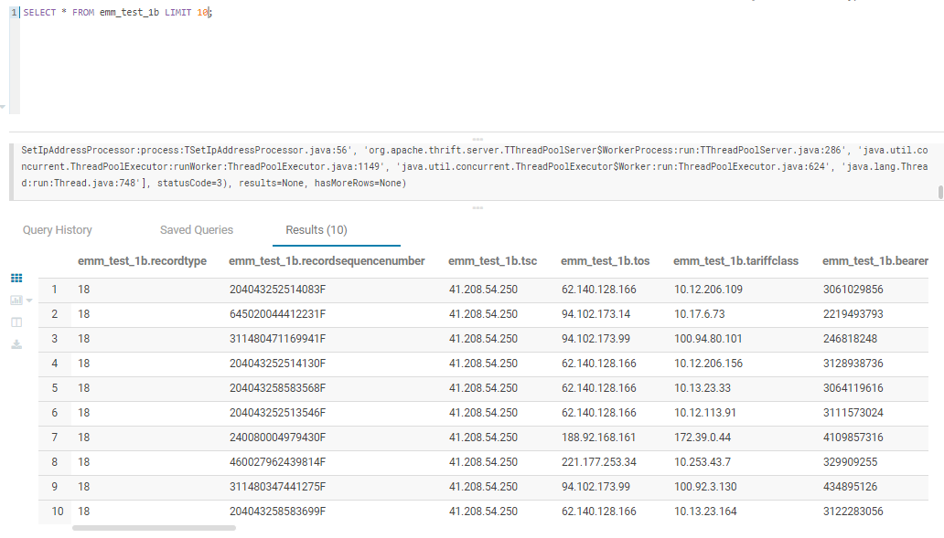

CREATE EXTERNAL TABLE emm_test_2b

( recordType STRING,

recordSequenceNumber STRING,

tSC STRING,

tOS STRING,

tariffClass STRING,

bearerServiceCode STRING,

callingNpiTon STRING,

callingMSISDN STRING,

calledNpiTon STRING,

calledMSISDN STRING,

calledRawMSISDN STRING,

origCalledNpiTon STRING,

originalCalledNumber STRING,

translatedNpiTon STRING,

translatedNumber STRING,

iMEI STRING,

iMSI STRING,

dateForStartOfCharging STRING,

chargeableDuration STRING,

timeFromRegToStartOfCharge STRING,

interruptTime STRING,

timeForStopOfCharge STRING,

geo_location STRING,

cause STRING,

firstLAC STRING,

firstCI STRING,

lastCI STRING,

incomingRoute STRING,

outgoingRoute STRING

)

ROW FORMAT DELIMITED

FIELDS TERMINATED BY ','

STORED AS TEXTFILE

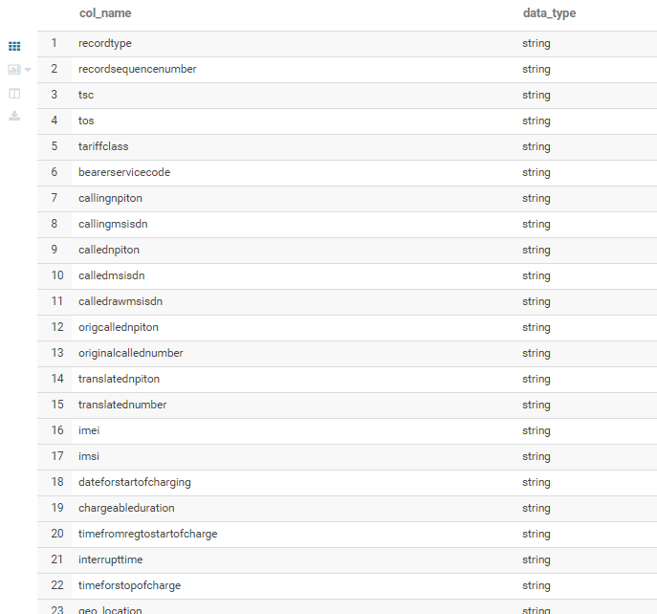LOCATION '/test_env/test_3/staging/EMM_2';

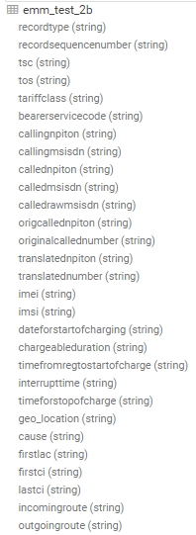  
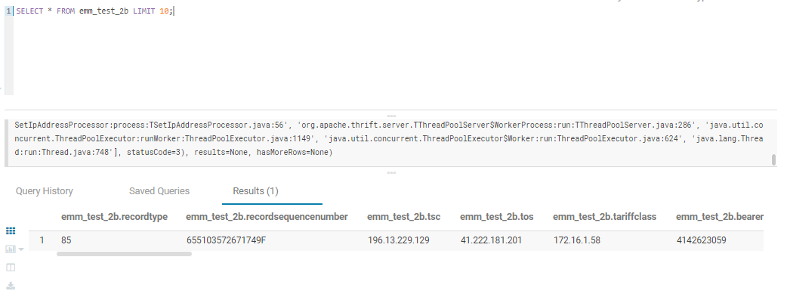

CREATE EXTERNAL TABLE emm_test_3b

( recordType STRING,

recordSequenceNumber STRING,

tSC STRING,

tOS STRING,

tariffClass STRING,

bearerServiceCode STRING,

callingNpiTon STRING,

callingMSISDN STRING,

calledNpiTon STRING,

calledMSISDN STRING,

calledRawMSISDN STRING,

origCalledNpiTon STRING,

originalCalledNumber STRING,

translatedNpiTon STRING,

translatedNumber STRING,

iMEI STRING,

iMSI STRING,

dateForStartOfCharging STRING,

chargeableDuration STRING,

timeFromRegToStartOfCharge STRING,

interruptTime STRING,

timeForStopOfCharge STRING,

geo_location STRING,

cause STRING,

firstLAC STRING,

firstCI STRING,

lastCI STRING,

incomingRoute STRING,

outgoingRoute STRING

)

ROW FORMAT DELIMITED

FIELDS TERMINATED BY ','

STORED AS TEXTFILE

LOCATION '/test_env/test_3/staging/EMM_3';

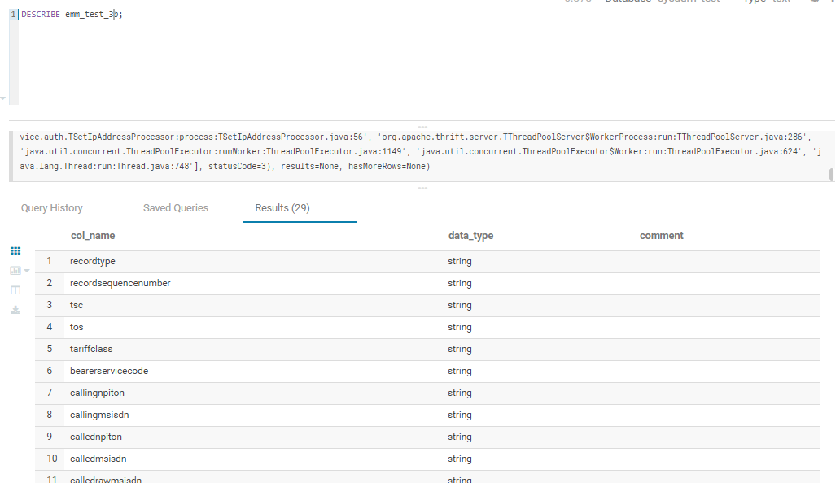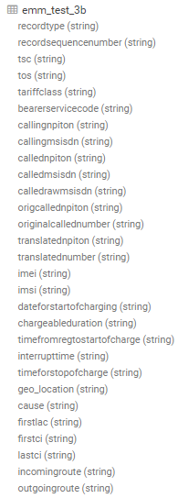

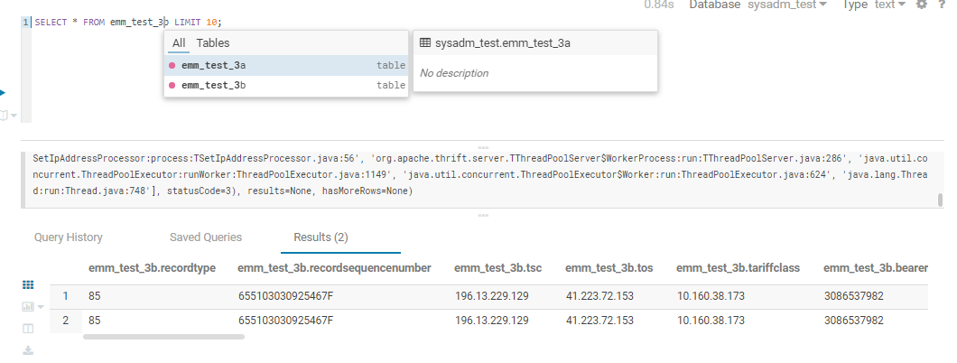

# Performing a union of two tables of EPG tables

Following step was to run a union query to create a new table by combining the relevant fields together as one schema.

**I ran the following query:**

INSERT INTO TABLE emm_1_2_3

SELECT recordtype, recordsequencenumber,tsc, tos, tariffclass, bearerservicecode, callingnpiton, callingmsisdn, callednpiton, calledmsisdn, calledrawmsisdn, origcallednpiton, originalcallednumber, translatednpiton, translatednumber, imei, imsi, dateforstartofcharging, chargeableduration, timefromregtostartofcharge, interrupttime, timeforstopofcharge, geo_location, cause, firstlac, firstci, lastci, incomingroute, outgoingroute

FROM emm_test_1b

UNION ALL

SELECT recordtype, recordsequencenumber,tsc, tos, tariffclass, bearerservicecode, callingnpiton, callingmsisdn, callednpiton, calledmsisdn, calledrawmsisdn, origcallednpiton, originalcallednumber, translatednpiton, translatednumber, imei, imsi, dateforstartofcharging, chargeableduration, timefromregtostartofcharge, interrupttime, timeforstopofcharge, geo_location, cause, firstlac, firstci, lastci, incomingroute, outgoingroute

FROM emm_test_2b

UNION ALL

SELECT recordtype, recordsequencenumber,tsc, tos, tariffclass, bearerservicecode, callingnpiton, callingmsisdn, callednpiton, calledmsisdn, calledrawmsisdn, origcallednpiton, originalcallednumber, translatednpiton, translatednumber, imei, imsi, dateforstartofcharging, chargeableduration, timefromregtostartofcharge, interrupttime, timeforstopofcharge, geo_location, cause, firstlac, firstci, lastci, incomingroute, outgoingroute

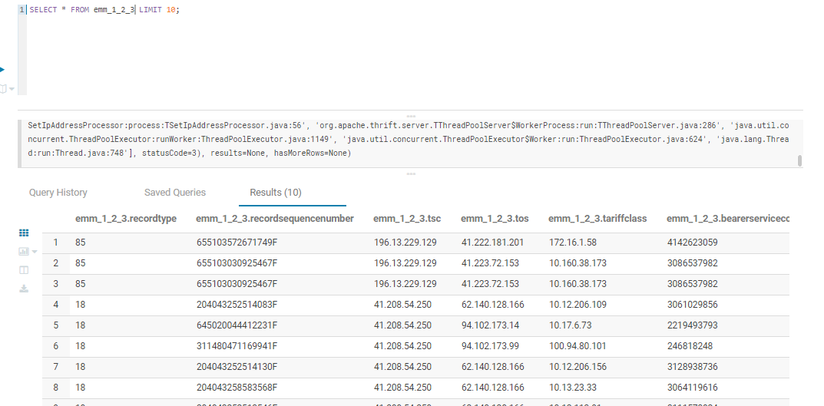 FROM emm_test_3b;

